**Product Packages Management**

## 

## **Create a purchase order from file**

* + You can create a purchase order by importing an Excel file using the **Purchase Order from File** feature.

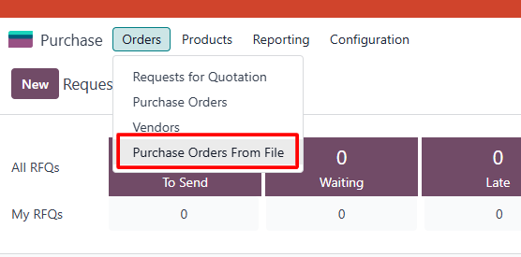

* Ensure the header of the purchase file is formatted correctly, as shown below:

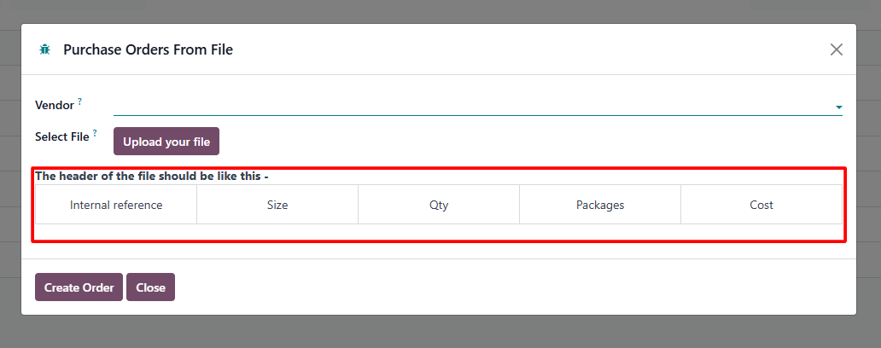

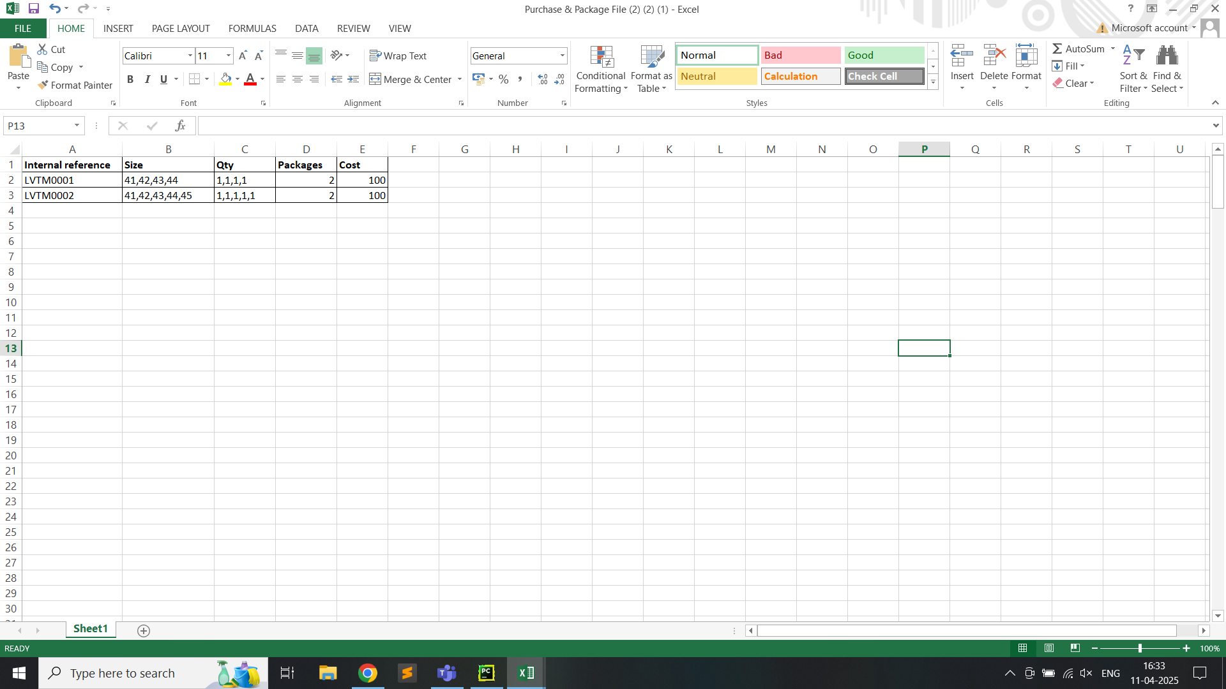

* Navigate to the import section and upload the prepared Excel file.
* Upon successful import, the system will automatically generate the purchase order.

## **Create packages from receipt**

* + To create packages, you can import an Excel file which used to create purchase order using the **Import Picking Lines** feature.

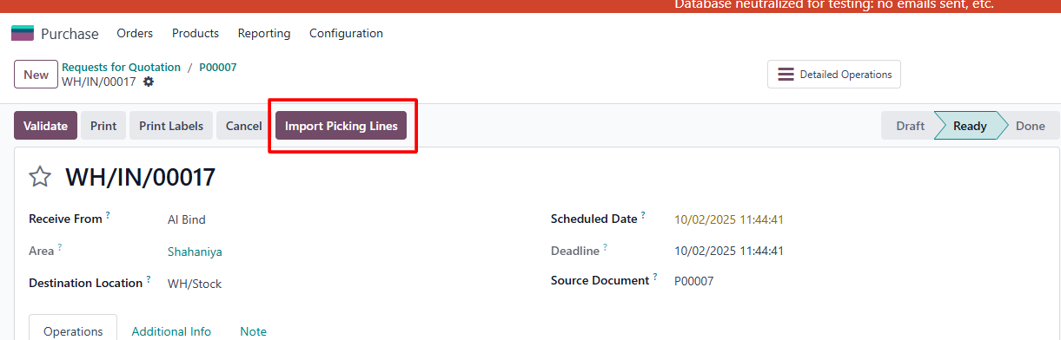

* Upon successful import, the system will automatically generate the required packages which can see in below in receipt.

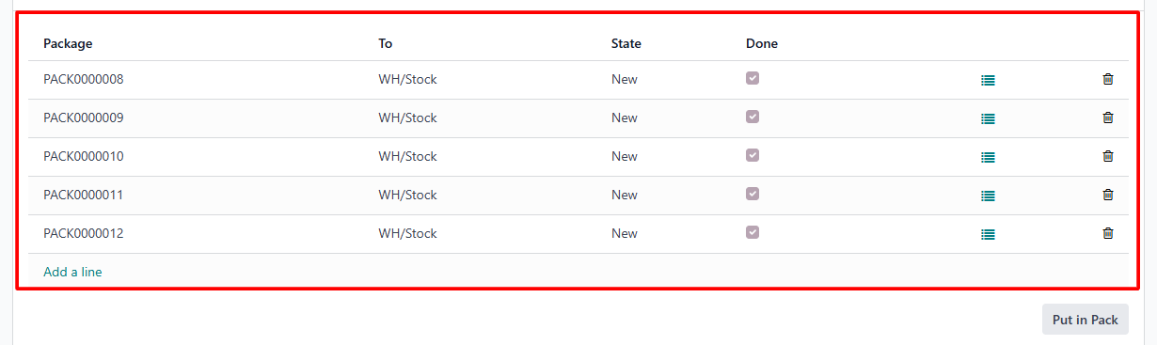

## **Internal transfer process**

* + After validating the receipt, the system will automatically create an internal transfer. This transfer allows you to move entire packages from the **WH/Input** location to the **WH/Stock** location by scanning the package barcode.

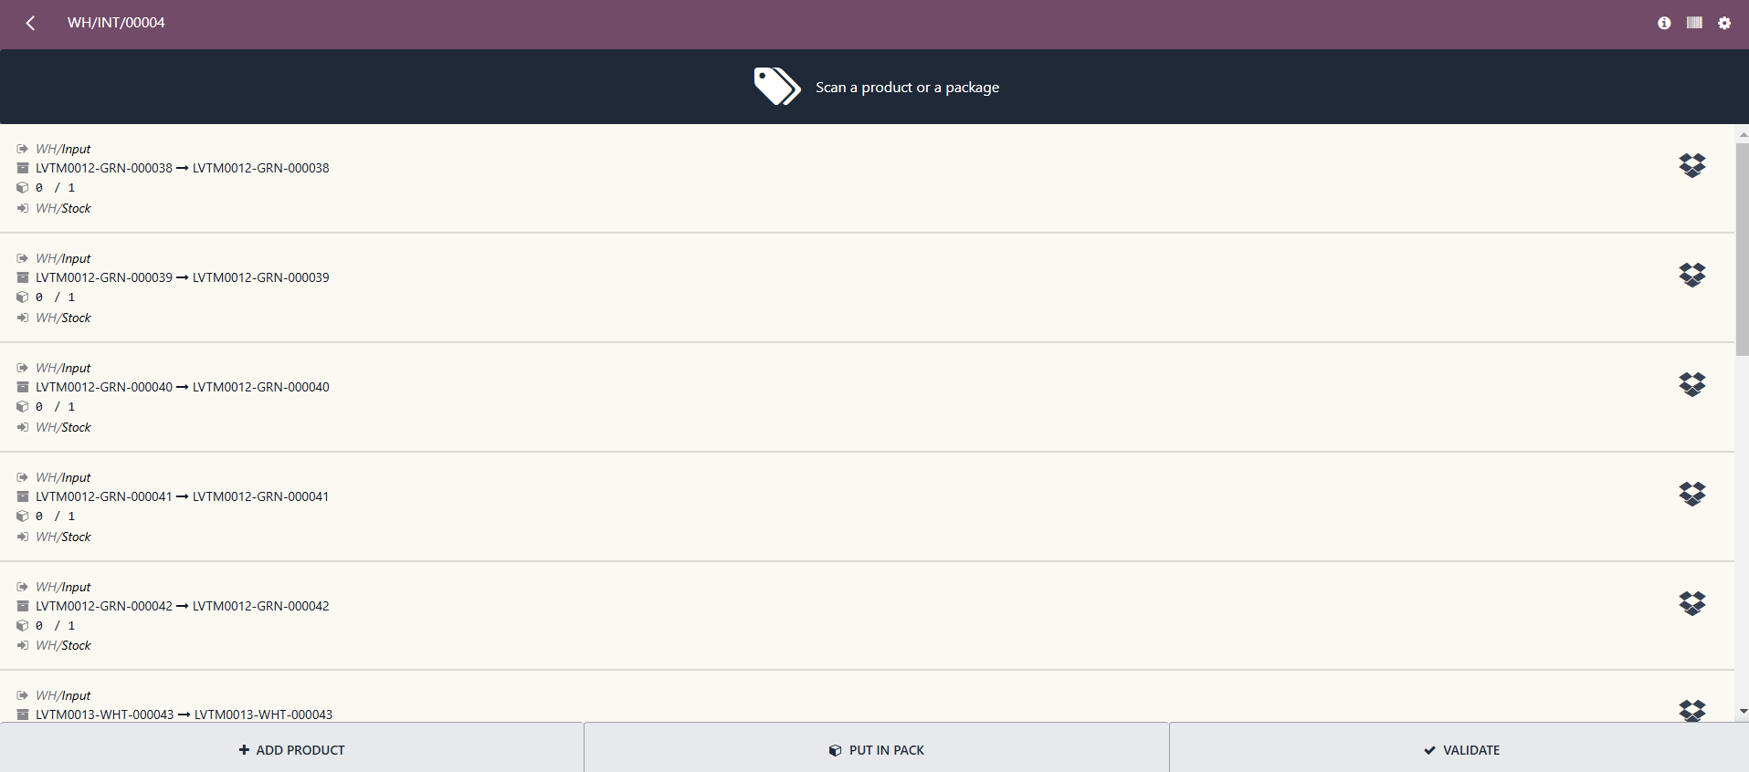

## **Create sale order of packages**

* + You can create a sale order by selecting packages from the **Package** button.
  + Click on the **Package** button to view available packages.

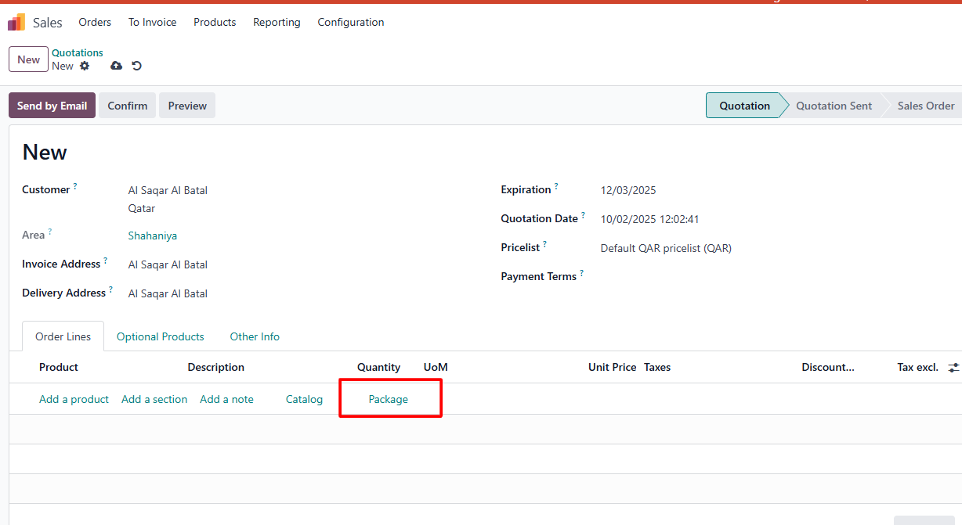

* The package view will open, displaying all available packages.
* Select the required packages and click on ‘Back to quotation’ and proceed to create the sale order.

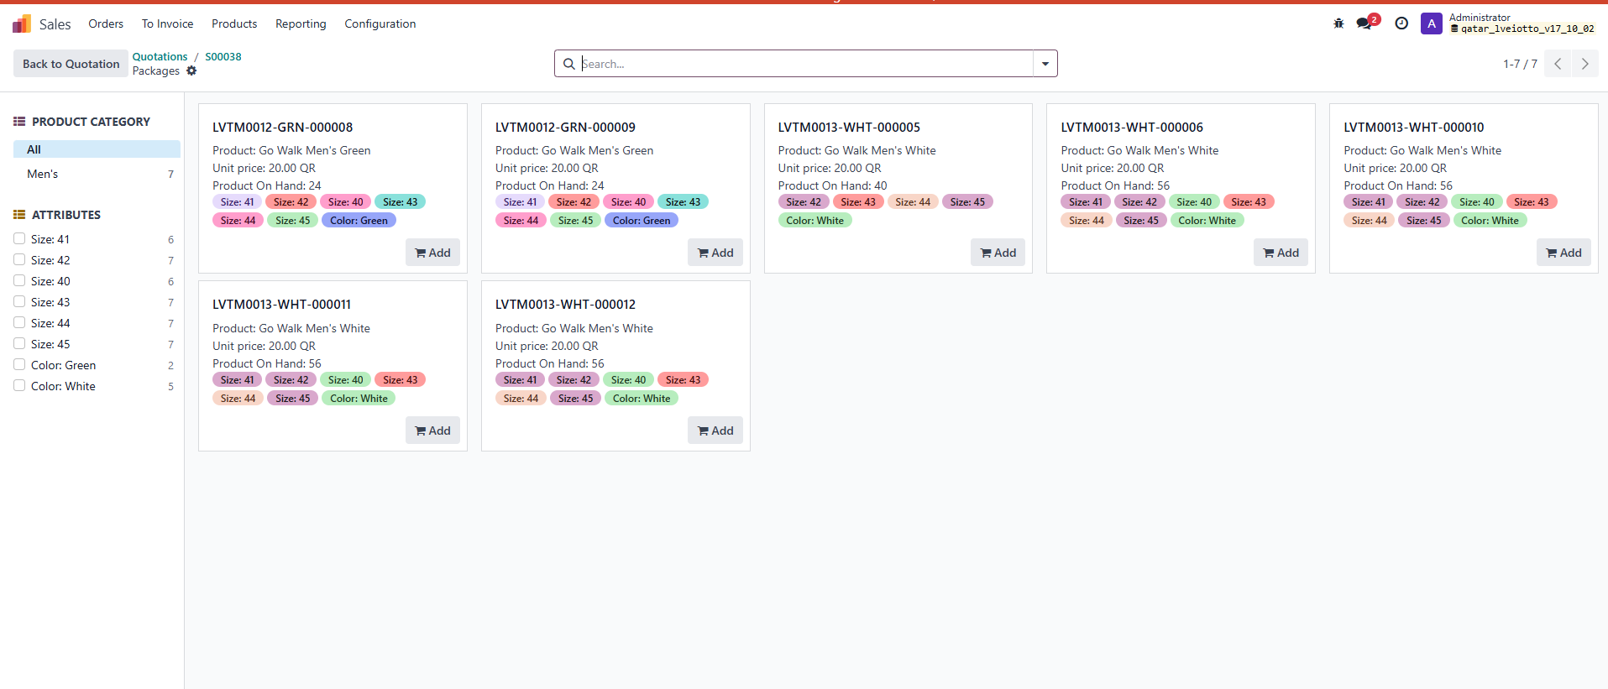

## **Transfer packages using transfer detail**

* + You can transfer packages from “WH/Stock” location to “WH/Output” location using the **Transfer Detail** feature, which generates a unique transfer record for each package.
  + Navigate to the **Transfer** **Details** section in the system.

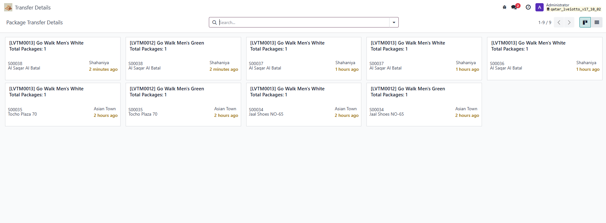

* Select the package(s) you want to transfer. And click no update button.

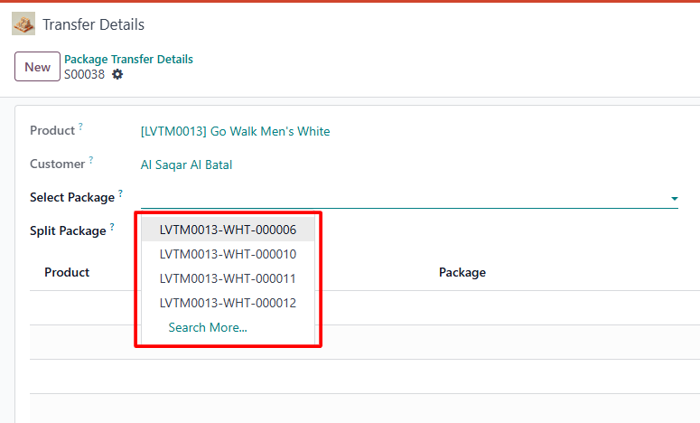

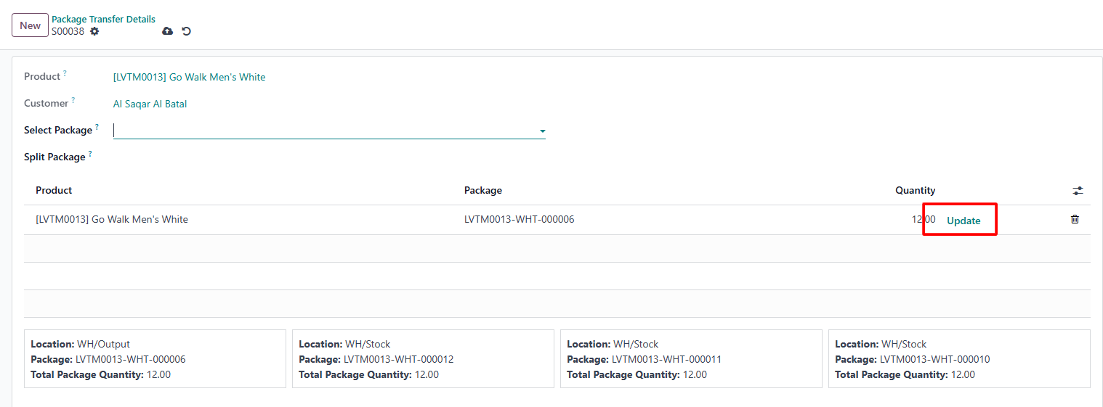

* After updating, the entire package will be transferred to the **WH/Output** location.

## **Split packages using transfer detail**

* + If you don’t want to transfer the entire package and prefer to split it, select the package from the **Split Package** option and choose the specific package to split.

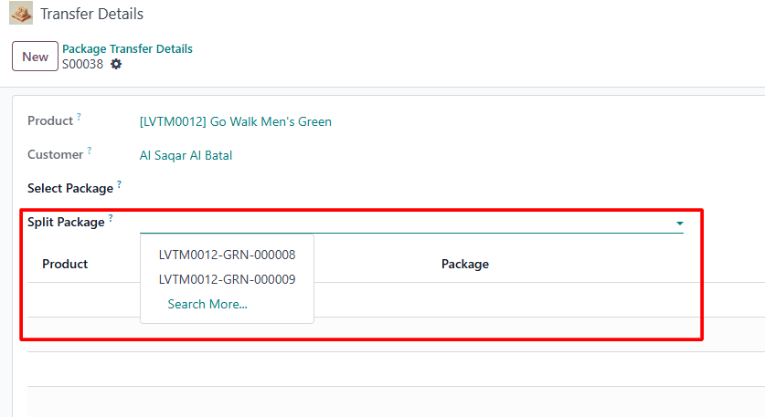

* After selecting the package, the **Split** button will become visible. Click on this button to proceed.

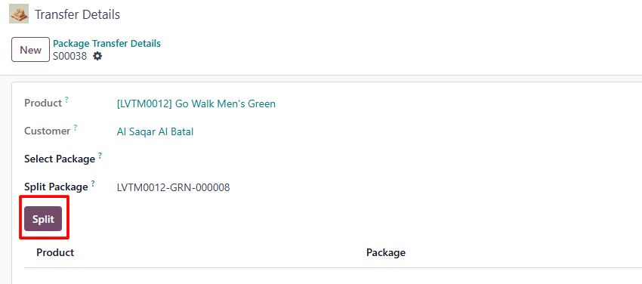

* After clicking the **Split** button, a pop-up window will appear, and in that window only those products are displayed which is required to split.
* If you split one package and update, then scan a second package, the remaining required quantity will be reserved from that package and displayed in the pop-up.

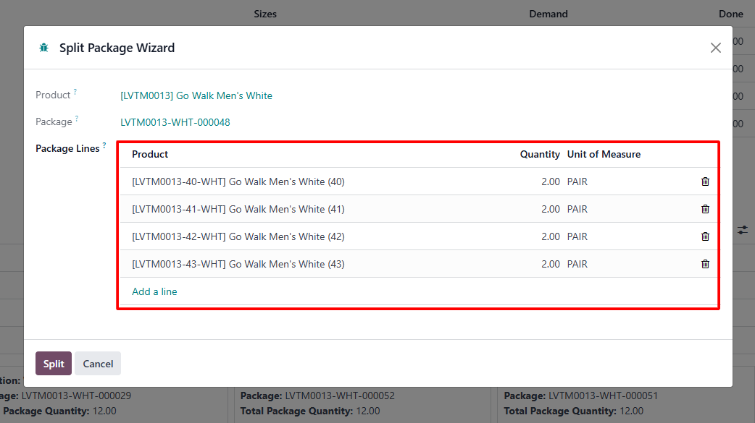

* You must update the split package before scanning another package. If you try to scan a second package without updating the first one, a warning will be displayed.

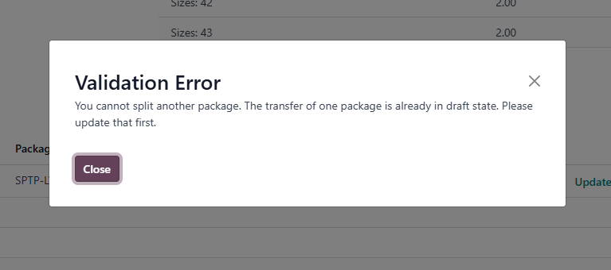

* After splitting the package, a new package will be created. Click on the **Update** button to transfer the newly created package to the **WH/Output** location.

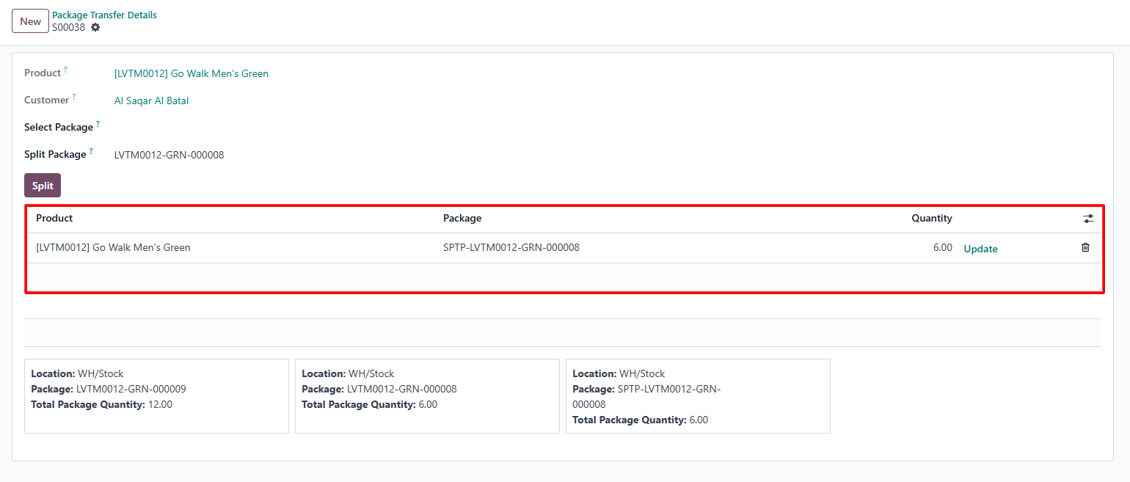

## **Packages deliver process**

* + In barcode delivery orders, you can deliver an entire package by scanning the package barcode.
  + Validate the delivery to complete the process.

